**Experiment 13**

FS19CO042

**Title**: Case Study on ER Model and EER Model.

**Theory:**

* Purpose of ER diagram

ENTITY RELATIONAL (ER) MODEL is a high-level conceptual data model diagram for database. ER modeling helps to analyze data requirements systematically to produce a well-designed database.

The Entity-Relation model represents real-world entities and the relationship

between them. It is considered best practice to complete ER modeling before implementing your database.

ER model can be converted to any other data model like relational or

network model for actual database implementation.

* Symbols used to represent components of ER diagram.

Entity Weak Entity

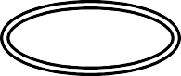Simple Multivalued

Attribute Attribute

Relationship Weak

Relationship

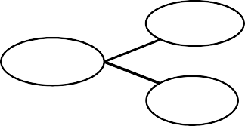Connecting line Composite attribute

Derived Key/single

Atrribute

Attribute valued attribute

* Purpose of EER diagram.

Enhanced entity-relationship (EER) diagrams are basically an expanded upon version of ER diagrams. EER models are helpful tools for designing databases with high-level models.

With their enhanced features, you can plan databases more thoroughly by delving into the properties and constraints with more precision.

EER mainly used to display following relationship concepts:

* 1. Super and sub class
  2. Specialization and Generalization
  3. Aggregation
* Generalization and Specialization concepts with example

**Generalization:** In generalization, two or more lower level entities are combined together to form one higher level entity. I.e.

Subclasses are combine together to form a super class It is a bottom to up approach.

One higher level entity can also be combined with other lower level entities to form another higher level entity.

Common properties among lower level entities to form higher level entity. For example,

Savings and current accounts are both accounts with added special properties.

Account

{ acc_no, balance}

{ int_rate }

is a

{ transactions }

Savings

Current

**Specialization:** In specialization, higher level entity is divided into two or more lower level entities. I.e. Super class is divided to form two or more subclasses.

It is a top-down approach.

This division is done on the basis of specialized properties in entity. For example,

Employee

{ eid, ename, salary }

{ int_rate }

is a

{ transactions }

Lecure

Librarian

{ course }

Peon

Lab assistant

{ job_type }

{ work_section } { Lab_assigned }

*ER diagram of restaurant management system:*

Cust_id

c_name

Bill_amount

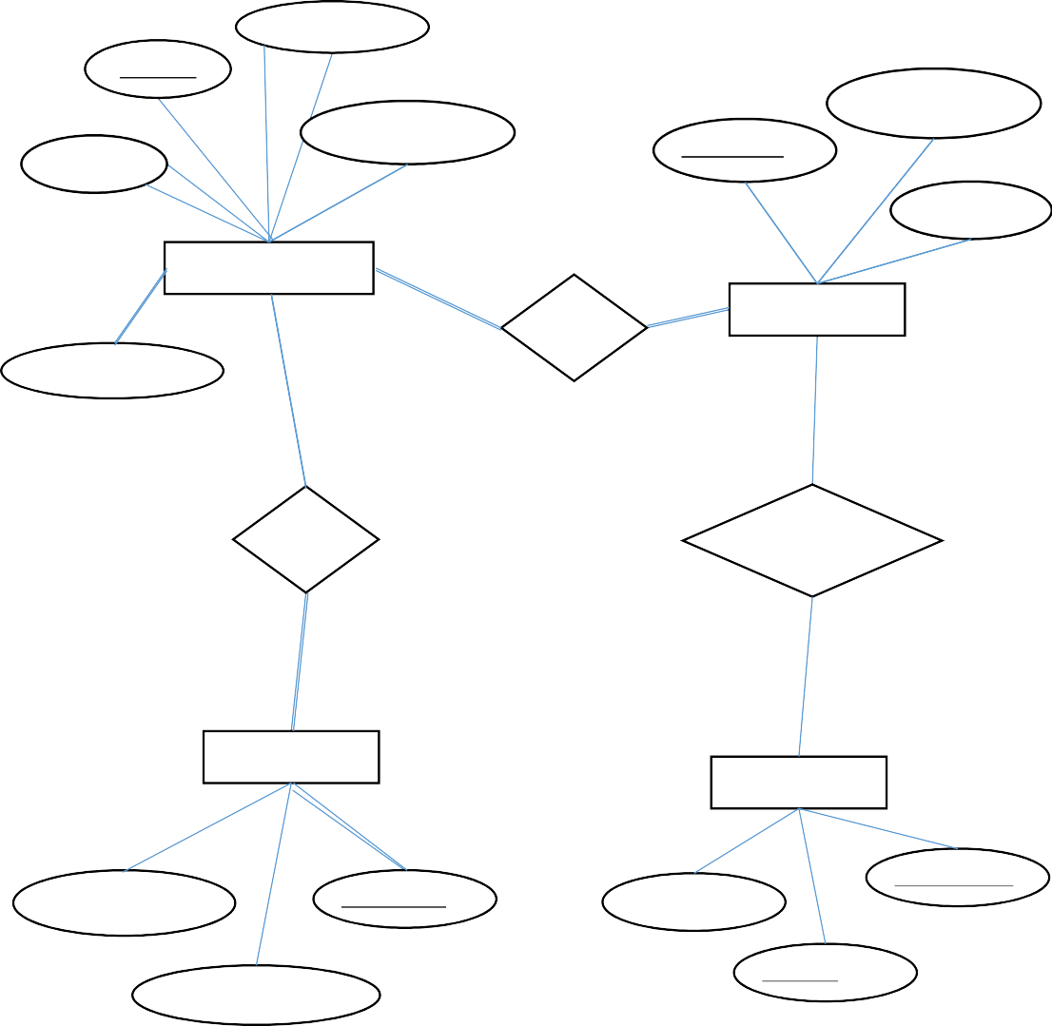Food_ordered

Waiter_id

service_Status

w_name

Service_status

Customer

N N

Served by

N

N

Waiters

N N

N

Pays to

Takes food from

1 N

N

1

Cashier

Chefs

cashier_name

cashier_id

Chef_name

chef_status

Table_assigned

chef_id

Conclusion: In this exp, we studied ER and EER models and made few exemplary diagrams.